Lecture 6.

Basic principles of antimicrobial therapy. Chemical therapeutic drugs. Antibiotics

The purpose of the lecture: To acquaint students with the basics of chemotherapy and the main groups of chemotherapeutic drugs and their mechanisms of action. Explain antibiotics, their classification, mechanisms of action, antibiotic resistance.

Lecture plan:
1. Chemotherapy.
- The concept of chemotherapy, the history of its development, the role of P.Erlich.
- Chemotherapeutic index.
- The main groups of chemical antimicrobials.
- Principles of chemotherapy of viral infections. Antivirus chemicals.
2. Antibiotics. The concept, discovery, history of antibiotics. The role of A. Fleming
- Classification of antibiotics according to their origin, chemical composition, mechanisms of antimicrobial action, spectrum of activity.
- Complications that can occur under the influence of antibiotics. Factors and mechanisms of bacterial resistance to antibiotics. Natural and acquired durability.
- Determination of antibiotic susceptibility of bacteria.

The year 1935 was an important one for the chemotherapy of systemic bacterial infections. Although antiseptics had been applied topically to prevent the growth of microorganisms, the existing antiseptics were ineffective against systemic bacterial infections. In 1935, the dye protosil was shown to protect mice against systemic streptococcal infection and to be curative in patients suffering from such infections. It was soon found that protosil was cleaved in the body to release p-aminobenzene sulfonamide (sulfanilamide), which was shown to have antibacterial activity. This first “sulfa” drug ushered in a new era in medicine. Compounds produced by microorganisms (antibiotics) were eventually discovered to inhibit the growth of other microorganisms. For example, Alexander Fleming was the first to realize the mold Penicillium prevented the multiplication of staphylococci. A concentrate from a culture of this mold was prepared, and the remarkable antibacterial activity and lack of toxicity of the first antibiotic, penicillin, were demonstrated. Streptomycin and the tetracyclines were developed in the 1940s and 1950s, followed rapidly by the development of additional aminoglycosides, semisynthetic penicillins, cephalosporins, quinolones, and other antimicrobials. All these antibacterial agents greatly increased the range of infectious diseases that could be prevented or treated. Although the development of new antibacterial antibiotics has lagged in recent years, some new classes of agents have been introduced, including the ketolides (e.g., telithromycin), glycylcyclines (tigecycline), and lipopeptides (daptomycin). Unfortunately, with the introduction of new chemotherapeutic agents, bacteria have shown a remarkable ability to develop resistance. The most common resistance mechanisms are summarized. Thus antibiotic therapy will not be the magical cure for all infections, as predicted; rather, it is only one weapon, albeit an important one, against infectious diseases. It is also important to recognize that because resistance to antibiotics is often not predictable, physicians must rely on their clinical experience for the initial selection of empirical therapy
and then refine their treatment by selecting antibiotics demonstrated to be active by in vitro susceptibility tests. Guidelines for the management of infections caused by specific organisms are discussed in the relevant chapters of this text.

ANTIMICROBIAL DRUGS USED IN COMBINATION
Indications
Possible reasons for using two or more antimicrobials simultaneously instead of a single drug are as follows:
1. To give prompt treatment in desperately ill patients suspected of having serious microbial infections. A good guess, usually based on available antibiogram data, about the most probable two or three pathogens, is made, and drugs are aimed at those organisms. Before such treatment is started, it is essential that adequate specimens be obtained for identifying the etiologic agent in the laboratory. Suspected gram-negative or staphylococcal sepsis in immunocompromised patients and bacterial meningitis in children are the foremost indications in this category.
2. To delay the emergence of microbial mutants resistant to one drug in chronic infections by the use of a second or third non–cross-reacting drug. The most prominent example is treatment for active tuberculosis.
3. To treat mixed infections, particularly those after massive trauma or those involving vascular structures. Each drug is aimed at an important pathogenic microorganism.
4. To achieve bactericidal synergism or to provide bactericidal action (see later discussion). In a few infections, such as enterococcal sepsis, a combination of drugs is more likely to eradicate the infection than either drug used alone. Such synergism is only partially predictable, and a given drug pair may be synergistic for only a single microbial strain. Occasionally, simultaneous use of two drugs permits significant reduction in dose and thus avoids toxicity but still provides satisfactory antimicrobial action.

Disadvantages
The following disadvantages of using antimicrobial drugs in combinations must always be considered:
1. The physician may believe that because several drugs are already being given, everything possible has been done for the patient, leading to relaxation of the effort to establish a specific diagnosis. It may also give a false sense of security.
2. The more drugs that are administered, the greater the chance for drug reactions to occur or for the patient to become sensitized to drugs.
3. The cost is unnecessarily high.
4. Antimicrobial combinations usually accomplish no more than an effective single drug.
5. Very rarely, one drug may antagonize a second drug given simultaneously (see later).
Mechanisms
When two antimicrobial agents act simultaneously on a homogeneous microbial population, the effect may be one of the following: (1) indifference (ie, the combined action is no greater than that of the more effective agent when used alone), (2) additive (ie, the combined action is equivalent to the sum of the actions of each drug when used alone), (3) synergism (ie, the combined action is significantly greater than the sum of both effects), or (4) antagonism (ie, the combined action is less than that of the more effective agent when used alone). All these effects may be observed in vitro (particularly in terms of bactericidal rate) and in vivo. The effects that can be achieved with combinations of antimicrobial drugs vary with different combinations and are specific for each strain of microorganism. Thus, no combination is uniformly synergistic.
Combined therapy should not be used indiscriminately; every effort should be made to use the single antibiotic of choice. In resistant infections, detailed laboratory study can at times define synergistic drug combinations that may be essential to eradicate the microorganisms.

Antimicrobial synergism can occur in several types of situations.
1. Two drugs may sequentially block a microbial metabolic pathway. Sulfonamides inhibit the use of extracellular PABA by some microbes for the synthesis of folic acid. Trimethoprim or pyrimethamine inhibits the next metabolic step, the reduction of dihydro- to tetrahydrofolic acid. The simultaneous use of a sulfonamide plus trimethoprim is effective in some bacterial (shigellosis, salmonellosis, Serratia species) and some other infections (pneumocystosis, malaria). Pyrimethamine plus a sulfonamide or clindamycin is used in toxoplasmosis.
2. A drug such as a cell wall inhibitor (a penicillin or cephalosporin) may enhance the entry of an aminoglycoside into bacteria and thus produce synergistic effects. Penicillins enhance the uptake of gentamicin or streptomycin by enterococci. Thus, ampicillin plus gentamicin may be essential for the eradication of Enterococcus faecalis, particularly in endocarditis. Similarly, piperacillin plus tobramycin may be synergistic against some strains of Pseudomonas species.
3. One drug may affect the cell membrane and facilitate the entry of the second drug. The combined effect may then be greater than the sum of its parts. For example, amphotericin has been synergistic with flucytosine against certain fungi (eg, Cryptococcus, Candida species).
4. One drug may prevent the inactivation of a second drug by microbial enzymes. Thus, inhibitors of β-lactamase (eg, clavulanic acid, sulbactam, tazobactam) can protect amoxicillin, ticarcillin, or piperacillin and other β-lactam agents from inactivation by β-lactamases. In such circumstances, a form of synergism takes place.

Antimicrobial antagonism is sharply limited by time– dose relationships and is therefore a rare event in clinical antimicrobial therapy. Antagonism resulting in higher morbidity and mortality rates has been most clearly demonstrated in bacterial meningitis. It occurred when a bacteriostatic drug (which inhibited protein synthesis in bacteria) such as chloramphenicol or tetracycline was given with a bactericidal drug such as a penicillin or an aminoglycoside. Antagonism occurred mainly if the bacteriostatic drug reached the site of infection before the bactericidal drug, if the killing of bacteria was essential for cure, and if only minimal effective doses of either drug in the pair were present. Another example is combining β-lactam drugs in treatment of P aeruginosa infections (eg, imipenem and piperacillin because imipenem is a potent β-lactamase inducer and the β-lactamase breaks down the less stable piperacillin).

ANTIMICROBIAL CHEMOPROPHYLAXIS
Anti-infective chemoprophylaxis implies the administration of antimicrobial drugs to prevent infection. In a broader sense, it also includes the use of antimicrobial drugs soon after the acquisition of pathogenic microorganisms (eg, after compound fracture) but before the development of signs of infection. Useful chemoprophylaxis is limited to the action of a specific drug on a specific organism. An effort to prevent all types of microorganisms in the environment from establishing themselves only selects the most drug-resistant organisms as the cause of a subsequent infection. In all proposed uses of prophylactic antimicrobials, the risk of the patient’s acquiring an infection must be weighed against the toxicity, cost, inconvenience, and enhanced risk of superinfection resulting from the prophylactic drug.

Prophylaxis in Persons of Normal Susceptibility Exposed to a Specific Pathogen
In this category, a specific drug is administered to prevent one specific infection. Particular examples are the injection of benzathine penicillin G intramuscularly once every 3 to 4 weeks to prevent reinfection with group A hemolytic streptococci in rheumatic patients; prevention of meningitis by eradicating the meningococcal carrier state with rifampin or ciprofloxacin; prevention of syphilis by the injection of benzathine penicillin G; prevention of plague pneumonia by oral administration of tetracycline in persons exposed to infectious droplets; prevention of leptospirosis with oral administration of doxycycline in a hyperendemic environment; and prevention of malaria in travelers to endemic areas of the world with various agents such as Malarone. Early treatment of an asymptomatic infection is sometimes called prophylaxis. Thus, administration of INH, 6 to 10 mg/kg/day (maximum, 300 mg/day) orally for 6 months, to an asymptomatic person who converts from a negative to a positive tuberculin skin test result may prevent later clinically active tuberculosis.

Prophylaxis in Persons of Increased Susceptibility
Certain anatomic or functional abnormalities predispose to serious infections. It may be feasible to prevent or abort such infections by giving a specific drug for short periods. Some important examples are listed here.
- Heart Disease
Persons with heart valve abnormalities or with prosthetic heart valves are unusually susceptible to implantation of microorganisms circulating in the bloodstream. Thus, infective endocarditis can sometimes be prevented if the proper drug can be used during periods of bacteremia. Large numbers of viridans streptococci are pushed into the circulation during dental procedures and operations on the mouth or throat. At such times, the increased risk warrants the use of a prophylactic antimicrobial drug aimed at viridans streptococci. For example, amoxicillin taken orally before the procedure and 2 hours later can be effective. Persons allergic to penicillin can take a macrolide or clindamycin orally (see American Heart Association recommendations at http://circ.ahajournals. org/content/118/8/887). Recommendations for prophylaxis following non-dental procedures vary depending upon the type of valvular abnormality. For example, prophylaxis is no longer recommended following gastrointestinal or genitourinary procedures in patients with rheumatic valvular
disease but may still be indicated in patients with congenital heart disease or those patients with prosthetic material. The reader is referred to the latest AHA guidelines for the most current recommendations.
B. Respiratory Tract Disease Trimethoprim–sulfamethoxazole orally or pentamidine by aerosol is used for prophylaxis for pneumocystis pneumonia in AIDS patients.
C. Recurrent Urinary Tract Infection
For certain women who are subject to frequently recurring urinary tract infections, the oral intake either daily or three times weekly of nitrofurantoin or trimethoprim– sulfamethoxazole can markedly reduce the frequency of symptomatic recurrences over long periods. Certain women tend to develop symptoms of cystitis after sexual intercourse. The ingestion of a single dose of antimicrobial drug (eg, nitrofurantoin, trimethoprim– sulfamethoxazole) can prevent postcoital cystitis by early inhibition of growth of bacteria moved from the introitus into the proximal urethra or bladder during intercourse.
D. Opportunistic Infections in Severe Granulocytopenia
Immunocompromised patients receiving organ transplants or antineoplastic chemotherapy often develop profound leukopenia. When the neutrophil count falls below 1000/μL, they become unusually susceptible to opportunistic infections, most often gram-negative sepsis. Such persons are sometimes given a fluoroquinolone, a cephalosporin, or a drug combination (eg, vancomycin, gentamicin, cephalosporin) directed at the most prevalent opportunists at the earliest sign—or even without clinical evidence—of infection. This is continued for several days until the granulocyte count rises again. Several studies suggest that there is benefit from
empiric therapy. Two clinical cases—liver and bone marrow transplants—presented illustrate the infections that occur in these patients and the antimicrobials used for
prophylaxis and treatment.

Prophylaxis in Surgery
A major portion of all antimicrobial drugs used in hospitals is used on surgical services with the stated intent of prophylaxis. Several general features of surgical prophylaxis merit
consideration:
1. The benefit of prophylactic antimicrobial agents for clean surgery has been established.
2. The type of antimicrobial agent that is chosen depends upon several factors: type of surgery and the knowledge of the endogenous microbiota; types of pathogens causing wound infections and their resistance patterns in a particular institution; patient allergies; penetration of the agent at the surgical site; cost and other considerations.
3. Cephalosporins, most commonly cefazolin, are the preferred agents.
4. The goal with administration of prophylactic agents is to ensure adequate tissue levels of the drug during the entire operative procedure. This may require redosing during long procedures (see list of recommendations for agents and dosing schedules in Bratzler et al).
5. The initial dose of systemic prophylactic antibiotic should be given within 60 min of the incision or within 120 min if vancomycin or a fluoroquinolone is used.
6. Prolonged administration of antimicrobial drugs tends to alter the normal microbiota of organ systems, suppressing the susceptible microorganisms and favoring the implantation
of drug-resistant ones. Thus, antimicrobial prophylaxis should usually continue for no more than 24 h after the procedure and ideally should be given only intraoperatively.
7. Systemic levels of antimicrobial drugs usually do not prevent wound infection, pneumonia, or urinary tract infection if physiologic abnormalities or foreign bodies are present. Topical antimicrobials for prophylaxis (eg, intravenous catheter site, closed urinary drainage, within a surgical wound, acrylic bone cement) have limited usefulness. Recent studies have demonstrated increased morbidity and mortality with S aureus postsurgical wound infections, particularly if the infection is caused by MRSA. Many hospitals perform presurgical nares surveillance screening for MRSA using either culture or nucleic acid amplification. Patients who are found to be colonized are treated with mupirocin ointment to the nares for 3–5 days along with chlorhexidine for bathing in an attempt to eliminate colonization before the procedure. Some investigators advocate the addition of vancomycin to a cephalosporin for intraoperative prophylaxis in patients known to be MRSA carriers.

Disinfectants
Disinfectants and antiseptics differ from systemically active antimicrobials in that they possess little selective toxicity. They are toxic not only for microbial pathogens but for host cells as well. Therefore, they can be used only to inactivate
microorganisms in the inanimate environment or, to a limited extent, on skin surfaces. They cannot be administered systemically. The antimicrobial action of disinfectants is determined by concentration, time, and temperature, and the evaluation of their effect may be complex. A few examples of disinfectants that are used in medicine or public health.
Antibacterial spectrum: Range of activity of an antimicrobial against bacteria. A broad-spectrum antibacterial drug can inhibit a variety of gram-positive and gram-negative bacteria, whereas a narrow-spectrum drug is active against a limited variety of bacteria.
Bacteriostatic antibiotic: Antibiotic that inhibits the growth of bacteria but does not kill.
Bactericidal antibiotic: Antibiotic that kills bacteria.
Minimum inhibitory concentration (MIC): Determined by exposing a standardized suspension of bacteria to a series of antimicrobial dilutions. The lowest antibiotic concentration that inhibits the growth of the bacteria is the MIC.
Minimum bactericidal concentration (MBC): Determined by exposing a standardized suspension of bacteria to a series of antimicrobial dilutions. The lowest antibiotic concentration that kills 99.9% of the population is referred to as the MBC.
Antibiotic combinations: Combinations of antibiotics that may be used to (1) broaden the antibacterial spectrum for empirical therapy or the treatment of polymicrobial infections, (2) prevent the emergence of resistant organisms during therapy, and (3) achieve a synergistic killing effect.
Antibiotic synergism: Combinations of two antibiotics that have enhanced bactericidal activity when tested together compared with the activity of each antibiotic.
Antibiotic antagonism: Combination of antibiotics in which the activity of one antibiotic interferes with the activity of the other (e.g., the sum of the activity is less than the activity of the most active individual drug).
β-Lactamase: An enzyme that hydrolyzes the β-lactam ring in the β-lactam class of antibiotics, inactivating the antibiotic. The enzymes specific for penicillins, cephalosporins, and carbapenems are the penicillinases, cephalosporinases, and carbapenemases, respectively.
Basic Mechanisms of Antibiotic Action
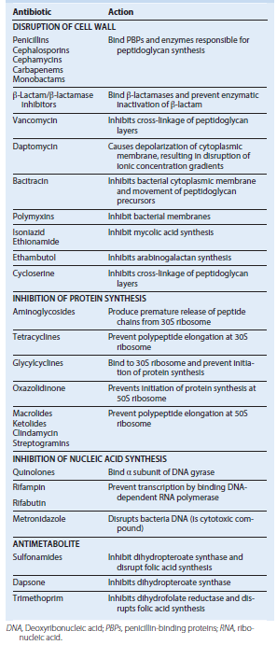

Basic sites of antibiotic activity.
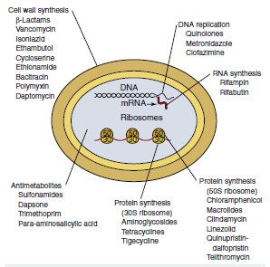

Mechanisms of Antibiotic Resistance
Inactivation of the antibiotic by bacterial enzymes Barriers prevent antibiotic access to the target
Bacteria pump antibiotic out of cell before bacterial growth is inhibited
Antibiotic target is altered so it is not recognized by the antibiotic
Antibiotic target is produced in excess so bacterial growth is not affected by the antibiotic
Antibiotic target is no longer needed for bacterial survival
Bacteria enter stage of dormancy in the presence of the antibiotic

Selected Examples of Cephalosporins and Cephamycins
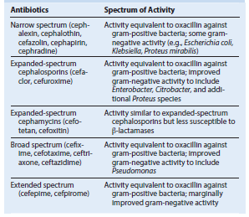

Other β-Lactam Antibiotics
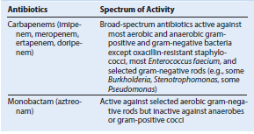

Inhibitors of Protein Synthesis
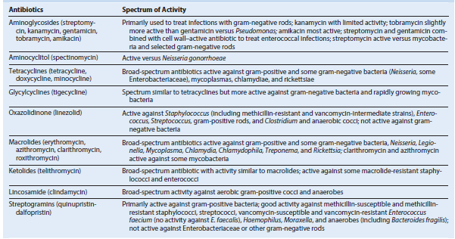

Quinolones
